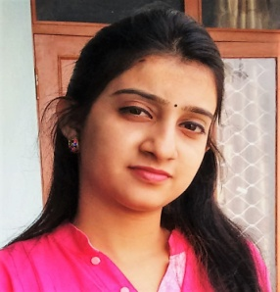

**Pounami Mukherjee**

* **Contact Details:**

Phone no.: 8981004771/9831677772

Email ID: pounami.mukherjee@gmail.com

Address: 27/F Hazra Bagan Lane, Kolkata-700015

* **Career Objectives:**

My objectives, as a professional, are to work efficiently dedicatedly and honestly in whatever task I undertake and achieve excellence in whatever job I do.

* **Academic Qualification:**

|  |  |  |  |  |
| --- | --- | --- | --- | --- |
| **Examination**  **Name** | **Board/Council**  **/University** | **Year of**  **passing** | **Discipline** | **Percentage of Marks/Percentile** |
| M.B.A | Annamalai University | pursuing | Marketing | ---- |
| Graduation | W.B.U.T. | 2014 | Hospital Management | 8.47(percentile) |
| H.S | W.B.C.H.S.E | 2011 | Science | 70% |
| MADHYAMIK | W.B.B.S.E | 2009 | General | 70% |

* **Professional Exposures:**
* Currently working in Universal Sompo general Insurance Co. Ltd. As an Marketing Officer.
  + **Job Role** –

1. Managing relationship with the branch managers and employees of the Bank
2. Meet Customers of the Bank (Lead generated by self/bank employees) for insurance cross-sell
3. Obtaining referrals and writing proposals for bank customers.
4. Conducting various engagement activities for Bank Employees and Customers  as initiated centrally or locally
5. Involvement in work site activities (putting up stalls and making presentations in corporate.
6. Taking responsibility of the Cluster/region/zone, fulfilling leads of the area & prospecting new business from the assigned areas.
7. Closing sale and following up on issuance.
8. Shall train the bank staff regularly on concepts in new product introductions or any other initiative launched for the bank

|  |  |
| --- | --- |
| **Training Organisation** | **Department** |
| 1. Fortis Healthcare, Anandapur, Kolkata | Human Resource ( Training and Development ) Department |
| 2. B M Birla heart research centre, Kolkata | Public Relation Department & Operations |
| 3. Bhagirathi Neotia Healthcare, Kolkata | Human Resource Department |

* **Internship:**
* **Language known:** English, Bengali, Hindi
* **Hobbies:** Travelling, Music

I, hereby, declare that the information furnished above is true to the best of my knowledge.

Thanking you,

Yours’ faithfully,

Pounami Mukherjee